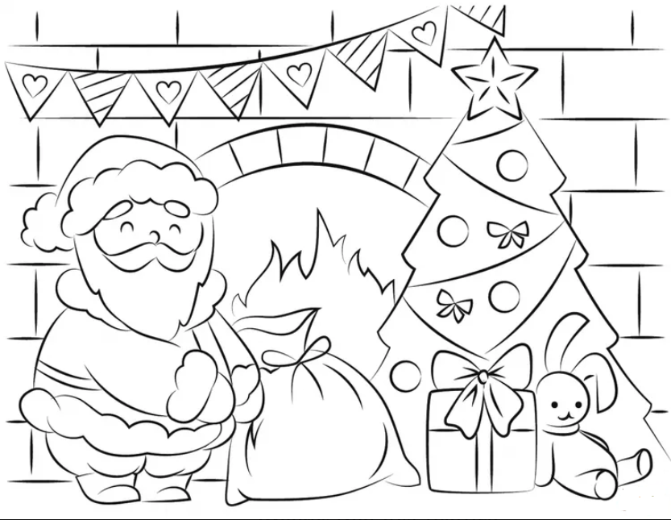

Name ________________________________________

Age ___________